First Presbyterian Church, Tucumcari
The Church With the Holy Spirit Window
Sunday, May 3, 2020 4th Sunday of Easter

Rev. Amy Pospichal, Pastor Marjorie McKenzie, Accompanist

“For All the Saints” Performed by First Plymouth Choir, Lincoln, Nebraska

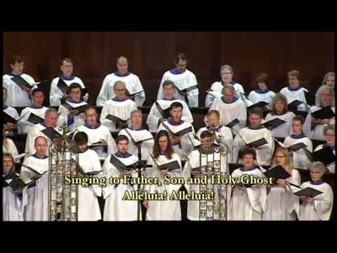

Call to Worship
God invites us to come in and go out and find pasture:
to come into the kingdom, into abundant life, into the light;
to go out to serve, out to live our faith, out to be the Body of Christ.
Christ calls us to hear his voice
and so we come to listen and seek and follow.
We stand at the threshold of God’s future,
the Spirit stands at the door and knocks.
Come, let us worship.

Prayer of Confession (prayer by Rev. Emily Schlaman Larsen, St. Andrews Presbyterian, Winston-Salem, NC)
The Lord is my shepherd, I shall not want.
But, O Lord, we are consumed with wanting more.
He makes me lie down in green pastures; he leads me beside still waters; he restores my soul.
But, O Lord, other pastures seem greener. The waters aren’t always still. Our souls still thirst.
He leads me in right paths for his name’s sake.
O Lord, we long to be led by you, though we may complain along the path.
Even though I walk through the darkest valley, I fear no evil; for you are with me; your rod and your staff– they comfort me.
And yet, O God, we do sometimes fear. May we feel your presence, your comfort and your forgiveness anew.
You prepare a table before me in the presence of my enemies; you anoint my head with oil; my cup overflows.
O God, sometimes we refuse to sit down at your table. Forgive us and help us to see your overflowing mercy.
Surely goodness and mercy shall follow me all the days of my life, and I shall dwell in the house of the Lord my whole life long.
Forgive us, God, and lead us into your house. (silence) Amen.

Assurance of Pardon
The Lord’s abundant mercy is from everlasting to everlasting.
Believe and live the good news:
In Jesus Christ, we are forgiven! Thanks be to God!
The peace of the Lord be with you.
And also with you.

Welcome to the Video Portion of our worship for this 4th Sunday in Easter. The Fourth Sunday of Easter is often called “Good Shepherd Sunday.” Before we begin this video, please go to the kitchen and get a little bit of juice or wine and a piece of bread. We will celebrate virtual communion after the sermon.
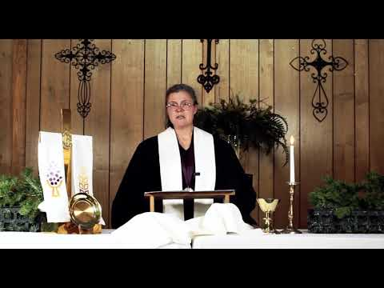
Psalm 23:1-6 (NRSV)
The Lord is my shepherd, I shall not want.
He makes me lie down in green pastures;
he leads me beside still waters;
he restores my soul.
He leads me in right paths
for his name’s sake.
Even though I walk through the darkest valley,
I fear no evil;
for you are with me;
your rod and your staff —
they comfort me.
You prepare a table before me
in the presence of my enemies;
you anoint my head with oil;
my cup overflows.
Surely goodness and mercy shall follow me
all the days of my life,
and I shall dwell in the house of the Lord
my whole life long.
Presentation of Offering and Offertory
(Offerings may be submitted to PO Box 367, Tucumcari, NM 88401. If you need to make a special arrangement, please call me at 708-0860. You can also visit our Facebook page for more information at First Presbyterian Church Tucumcari, NM.)

*Doxology Praise God from whom all blessings flow. Praise Him all creatures here below. Praise Him above ye heavenly hosts. Praise Father, Son and Holy Ghost. Amen.
*Let us pray with gratitude:
Lord, we thank you for all that we have. We thank you for your sustenance and for the power you have given to your church. Strengthen our walks of faith and help us see where we can generously give God’s gift of the Gospel to others in these times. Amen.

*Congregational Response We give Thee but Thine own. Whatever the gift may be;
All that we have is Thine alone, A trust, O Lord, from Thee. Amen

Prayer for Illumination
Risen Christ,
you opened the scriptures to your disciples
and made their hearts burn within them.
Open our eyes, our ears, and our hearts,
so we might recognize you once again
in these words of scripture,
by the power of the Holy Spirit. Amen.

1 Peter 2:19-25
¹⁹For it is a credit to you if, being aware of God, you endure pain while suffering unjustly. ²⁰If you endure when you are beaten for doing wrong, what credit is that? But if you endure when you do right and suffer for it, you have God’s approval. ²¹For to this you have been called, because Christ also suffered for you, leaving you an example, so that you should follow in his steps.
²² “He committed no sin,
and no deceit was found in his mouth.”
²³When he was abused, he did not return abuse; when he suffered, he did not threaten; but he entrusted himself to the one who judges justly. ²⁴He himself bore our sins in his body on the cross, so that, free from sins, we might live for righteousness; by his wounds you have been healed. ²⁵For you were going astray like sheep, but now you have returned to the shepherd and guardian of your souls.
Gospel John 10:1-10
¹“Very truly, I tell you, anyone who does not enter the sheepfold by the gate but climbs in by another way is a thief and a bandit. ²The one who enters by the gate is the shepherd of the sheep. ³The gatekeeper opens the gate for him, and the sheep hear his voice. He calls his own sheep by name and leads them out. ⁴When he has brought out all his own, he goes ahead of them, and the sheep follow him because they know his voice. ⁵They will not follow a stranger, but they will run from him because they do not know the voice of strangers.” ⁶Jesus used this figure of speech with them, but they did not understand what he was saying to them.
⁷So again Jesus said to them, “Very truly, I tell you, I am the gate for the sheep. ⁸All who came before me are thieves and bandits; but the sheep did not listen to them. ⁹I am the gate. Whoever enters by me will be saved, and will come in and go out and find pasture. ¹⁰The thief comes only to steal and kill and destroy. I came that they may have life, and have it abundantly.”

Sermon: “Guardian of Souls” Rev. Amy Pospichal

As so many of us are cooped up in our homes, at the order of our governor, we might feel some particularly strange emotions about today’s gospel reading. We might jump to the symbolism of the Good Shepherd, as His flock, held captive in a fold where the shepherd kept his sheep safe at night.
Now, picture yourself being called out by name, and going for a daylit walk in the countryside. The flock is grazing green grass and drinking from fresh waters, under the watch of the shepherd. The shepherd looks out for their health, protection and the main tools of this trade are a rod (like a billy club) and a staff, to pull a sheep close for inspection. But they are not completely enclosed at night. For the shepherd would bring them to a cave, or a 4-5 foot barricade with an open doorway. Then, the shepherd would lie down in the doorway, just in case of predators. By being as the door or gate to the sheep, this shepherd would have to place his own life at risk.
The life of the flock and the shepherd is a personal one. John’s gospel says, “’…the sheep hear his voice. He calls his own sheep by name and leads them out. ⁴ When he has brought out all his own, he goes ahead of them, and the sheep follow him because they know his voice. ⁵ They will not follow a stranger, but they will run from him because they do not know the voice of strangers.’”
The shepherd calls the sheep, knows them by name, and they recognize his voice. They have a routine together, and it is built on a relationship of trust and care. The sheep follow only him because they know his voice. It’s a personal relationship which the shepherd has with each of his sheep. The shepherd would have even smelled like this sheep. The shepherd’s entire life was around these sheep, spending more with the animals than with other humans. They all trust the shepherd, who had little in the way of protection, but had his own life to give. The shepherd lays down his life for his flock. Literally.
But he did even more for his sheep than that. The shepherd had an intimate knowledge of his sheep, inspecting their bodies regularly for injury or pests. Psalm 23 mentions anointing the head with oil, which I always thought was some kind of holy anointing as with marking the ancient Jewish priesthood. But this was also done to sheep. It was done to help sheep who had parasites. The traditional combination was something similar to a mix of linseed oil, tar and sulfur. Many of us have a similar intimacy with our pets, especially as they grow older, checking their ears, brushing them, giving them pills and trying to understand them when they communicate with us.
The shepherd, of Christ’s day, was constantly on the lookout for troubled sheep. Imagine how much better it must have felt for the shepherd to rub oil onto the animal’s head. It was a one-on-one experience. In the words of Rev. Stephen Davey, “There is the larger picture, where I am part of the flock. And there is also the intimate picture that Jesus Christ knows our name and sees when we have need of a personal, intimate touch. He then pulls us close [with his shepherd’s crook] and administers whatever we need.” (https://www.wisdomonline.org/media/messages/series_list/?filter=book&book=35, https://farmandanimals.com/why-do-shepherds-put-oil-on-sheep/)
So the good news in this story is that Jesus smells like his sheep. He smells like us, and like all those who listen and follow his voice. From a bodily perspective, it means Jesus is our brother and shepherd. He is the human face of God, God’s incarnate Word. It means that we share something in common with him, and that is His humanity. He carries a holy aroma that helps us identify him and stay near. From a spiritual perspective, we may be assured that he knows us so intimately, knows our needs, leads us where we need to go (see Psalm 23). As it says in 1 Peter, he is the “guardian of our souls.”
Sometimes we mistakenly think that our faith is about understanding the truths of our faith, or professing a particular creed of beliefs, or learning the Holy Scriptures. But these things are only secondary. Our faith, at its core, is about our relationship with God, and with Jesus, the one who showed us the face of God. I recently heard a story of a retired priest, who attended a dinner party, entertained by a celebrity. After the performance, the celebrity said, “I’m taking requests now.” The priest said, “Psalm 23.” The entertainer said, “Only if you will do it too, Father.” After each of them recited Psalm 23, the entertainer said, “Folks, you heard me just talk to your ears. This man really knows the Good Shepherd, for he spoke to your heart.” (https://philipchircop.wordpress.com/tag/psalm-23/)
So as you feel barricaded against this current pandemic, remember that you are also protected further by the Good Shepherd. There is an open door, but he leads us out and in to find what we need. He knows you intimately and offers healing balm. He laid down his life for you. For such a gift as that, we can trust where he is leading us next. Amen.
Service of Holy Communion
Invitation to the Table
This is not a Presbyterian Table. Nor is it a Protestant one. It is the Lord’s table. Anytime we eat and drink here, we are guests and friends of our Lord Jesus, the host. On the night before his death, Jesus ate with his disciples and when they were finished, he took bread, broke it, and gave it to them saying…

Great Prayer of Thanksgiving
The Lord be with you.
And also with you.
Lift up your hearts.
We lift them up to the Lord.
Let us give thanks to the Lord our God.
It is right to give our thanks and praise.
It is right and good to give you thanks and praise, Eternal Shepherd,
for walk you with us each and every day,
through green pastures,
beside still waters,
along the summits of our rejoicing
and in the valleys of our uncertainty.
Your presence has sustained us from generation to generation,
in the wisdom of our mothers and fathers,
in the challenges of your prophets,
and most of all in our risen Lord Jesus Christ,
the great and mighty shepherd of all.
So we raise our voices with all our companions on this journey,
giving you thanks and praise now and always:
Holy, holy, holy Lord, God of power and might,
heaven and earth are full of your glory.
Hosanna in the highest!
Blessed is the one who comes in the name of the Lord.
Hosanna in the highest!
In Christ you came among us to be our true divine companion,
to know our humanity and to make us whole.
In Christ you suffered even the pains of death,
but nothing could take away the fullness of your life.
In Christ you rose to new life,
breaking the bonds of death once and for all
so that all creation might live in the fullness of hope.
Remembering all that you have done and are doing and will do,
we take these gifts of bread and cup
to celebrate your presence with us in Christ and in one another.
Gracious God,
pour out your Holy Spirit upon us
and upon these gifts of bread and cup,
that the bread we break
and the cup we bless
may be the communion of the body and blood of Christ.
By your Spirit make us one with Christ
that we may be one with all who share this feast,
united in ministry in every place.
As this bread is Christ’s body for us,
send us out to be the body of Christ in the world.
Guide us as we embody your love and joy
in all our lives and in your world.
Help us to walk with one another in mercy and peace,
in justice and joy,
each and every day,
that your abundant grace and faith might flow in us wherever we walk,
until we dwell secure in your love all our days.
Through Christ, with Christ, in the unity of the Holy Spirit,
all glory and honor are yours, almighty God and Good Shepherd,
now and forever. Amen.
Before we close with a little music, prepare to receive the benediction:
Beloved, we have heard and trusted in
the good news of Jesus Christ.
Go now into the world to do and see still greater things,
to open heaven upon earth
and bear witness to eternal life today;
in the name of the Father,
and of the Son,
and of the Holy Spirit. Amen.

‘The Lord of Sea and Sky” National Youth Choir of Scotland
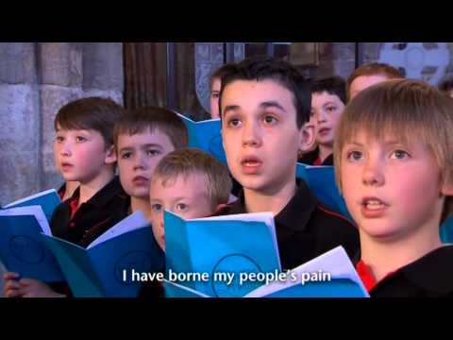

THE LIFE OF THE CHURCH
Potluck Hosts needed: June 21st is Potluck Sunday at our church. However, we do not have a host/s for that day. Please consider being host, or sharing that responsibility with another person. It makes all the difference in the world!

During the Pandemic, Face Masks: Several people in our church are making protective face masks for us to wear in public from fabric. If you need one, please let me know. I have 3 new ones available and more are being made!

Please,
Pray for peace in the Middle East, including Iraq and Afghanistan
Pray for a safe return of daughters and sons from combat
Pray for our global community and those in the midst of disaster
Pray for America and her enemies, that all would seek peace!
Pray for all the people and leaders in our local community
Pray for those who are seeking a deeper spiritual life.
Pray for all first responders
Pray for our church, national and local
Pray for our Presbytery and our pastor

PRAYER REQUESTS FOR COMFORT AND HEALING
Betty (Glenda’s sister) – awaiting a diagnosis
Family and friends of Becky Bryant in their grief
Cheryl Brewer – cancer hospice
Emma Lowther, Lou Sims’ great niece – ongoing heart trouble
Davis (Russell’s son) – Air Force boot camp in San Antonio
Glenda Coles – broken foot and injured knee
Gloria (Teresa Gallegos-Brake’s sister) – still having health problems
Gracie Whitson – still recovering
Ida Macias – broken femur
Jenna Morris, knee problems
Jim Enriquez & family - medical problems
Julie Sursa – difficulty walking
Karen Foster – chemo for cancer
Kaylie McKnight and her family
Konnor (grandson of the Bonds) – at sea in the Navy
Kurt Goldston - chemotherapy
Levi Mericle – thyroid cancer
Misty Tompkins – stiff person syndrome
Nancy Sallee – two health problems
Family and friends grieving for Paul Quintana
Roseann Mendez battling liver cancer
Ruth Johnson – physical problems
Sharon Huffman – continued health problems
Sharon McCauley – awaiting surgery
Shay – requested by Julie Sursa
Sheila Martinez – Heart Trouble, diabetes, vision problems
Sondra Moore Carlson – chemotherapy
Sonia (Betty Faye’s daughter) recovering from stroke
Stacie (Glenda’s friend) – medical problems
Tom Anderson – chemotherapy and side effects

