First Presbyterian Church, Tucumcari
The Church With the Holy Spirit Window
Sunday, April 26, 2020 3rd Sunday of Easter

Rev. Amy Pospichal, Pastor Marjorie McKenzie, Accompanist

“It is Well With My Soul” arranged by Rene Clausen First Plymouth Church, Lincoln, NE
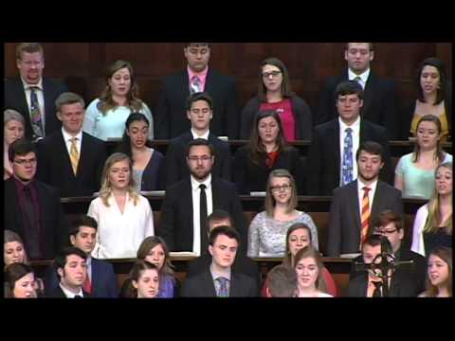

Call to Worship
Risen One, you accompany us on our journey, but we don’t always see you or know you are there
Be with us as we meet in fellowship today
Our hearts burn within us as you teach us your Way, and we want to love as you love
Be with us as we follow your Way
Our eyes are opened as you break bread and pour wine for us.
Be with us as we remember your life, death, and resurrection. Amen!

Welcome to the Video Portion of our worship for this 3rd Sunday in Easter. I hope that you have found something to feed your soul over the last few weeks in isolation. Let us begin with a prayer of confession. You are welcome to say this responsive prayer of confession with me using the text below.

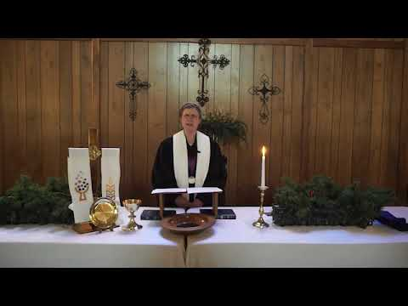
Prayer of Confession
We confess, Holy One, that often our faith is conditional. We trust you when we can see where you are going, and we believe your word when it makes sense with what we already know. The rest of the time…our voices can often be heard in the midst of the crowd demanding that you meet our expectations. We are truly sorry for ignoring the sign of your presence among us, when our hearts burn with your Holy Spirit. Forgive us. Help us to trust where we have not seen. Teach us your way, foolish step by foolish step, until we find ourselves living your wisdom. (silence) Amen.
Assurance of Pardon
The Lord’s abundant mercy is from everlasting to everlasting.
Believe and live the good news:
In Jesus Christ, we are forgiven! Thanks be to God!
The peace of the Lord be with you.
And also with you.

Psalm 116:1-4, 12-19
I love the LORD, because he has heard
my voice and my supplications.
Because he inclined his ear to me,
therefore I will call on him as long as I live.
The snares of death encompassed me;
the pangs of Sheol laid hold on me;
I suffered distress and anguish.
Then I called on the name of the LORD:
“O LORD, I pray, save my life!”
What shall I return to the LORD
for all his bounty to me?
I will lift up the cup of salvation
and call on the name of the LORD,
I will pay my vows to the LORD
in the presence of all his people.
Precious in the sight of the LORD
is the death of his faithful ones.
O LORD, I am your servant;
I am your servant, the child of your serving girl.
You have loosed my bonds.
I will offer to you a thanksgiving sacrifice
and call on the name of the LORD.
I will pay my vows to the LORD
in the presence of all his people,
in the courts of the house of the LORD,
in your midst, O Jerusalem.
Praise the LORD!
Prayers of the People (Prayer by Katherine Kussmaul, St. Giles Presbyterian Church, Raleigh, NC)

Christ is Risen!
He is Risen Indeed!
Risen Lord, hear our cry for help –
for those surrounded by the shroud of death
for those covered by the mantle of dying
for those hemmed-in by illness, visible or veiled
hear our cry for help…
for those weighed down with worries
for those carrying the burden of distress
for those overwhelmed by isolation
hear our cry for help…
for those who are weary
for those who are tattered and worn
for those who collapse from exhaustion
hear our cry for help…

(silence)

Risen Lord, hear our cry of thanksgiving –
for the graciousness with which you hear
for the patience with which you listen
for the grace with which you care
hear our cry of thanksgiving…
for the ways you accompany us through deep valleys
for the ways you lead us to still meadows
for the ways you provide all we need
hear our cry of thanksgiving…
for transforming death in resurrection life
for blessing and breaking ordinary bread
for opening our eyes to recognize you
hear our cry of thanksgiving…

(silence)

Risen Lord, hear our cry for communities of faith –
that we retain memory of being together
that we embrace unity in the reality of distance
that we foresee a future side-by-side, hand-in-hand
hear our cry for communities of faith…
that we sense purpose beyond ourselves
that we perceive the needs of creation
that we stretch ourselves to respond
hear our cry for communities of faith…
that our ways be formed by Your Way
that our lives be shaped by Your Life
that our love be Your Love
hear our cry for communities our faith…
And hear us as we pray together…. (The Lord’s Prayer)

Presentation of Offering and Offertory
(Offerings may be submitted to PO Box 367, Tucumcari, NM 88401. If you need to make a special arrangement, please call me at 708-0860. You can also visit our Facebook page for more information at First Presbyterian Church Tucumcari, NM.)

*Doxology Praise God from whom all blessings flow. Praise Him all creatures here below. Praise Him above ye heavenly hosts. Praise Father, Son and Holy Ghost. Amen.
*Let us pray with gratitude:
Lord, we thank you for all that we have. We thank you for your sustenance and for the power you have given to your church. Strengthen our walks of faith and help us see where we can generously give God’s gift of the Gospel to others in these times. Amen.

*Congregational Response We give Thee but Thine own. Whatever the gift may be;
All that we have is Thine alone, A trust, O Lord, from Thee. Amen

Prayer for Illumination
Risen Christ,
you opened the scriptures to your disciples
and made their hearts burn within them.
Open our eyes, our ears, and our hearts,
so we might recognize you once again
in these words of scripture,
by the power of the Holy Spirit. Amen.

Gospel Luke 24:13-35
¹³Now on that same day two of them were going to a village called Emmaus, about seven miles from Jerusalem, ¹⁴and talking with each other about all these things that had happened. ¹⁵While they were talking and discussing, Jesus himself came near and went with them, ¹⁶but their eyes were kept from recognizing him. ¹⁷And he said to them, “What are you discussing with each other while you walk along?” They stood still, looking sad. ¹⁸Then one of them, whose name was Cleopas, answered him, “Are you the only stranger in Jerusalem who does not know the things that have taken place there in these days?” ¹⁹He asked them, “What things?” They replied, “The things about Jesus of Nazareth, who was a prophet mighty in deed and word before God and all the people, ²⁰and how our chief priests and leaders handed him over to be condemned to death and crucified him. ²¹But we had hoped that he was the one to redeem Israel. Yes, and besides all this, it is now the third day since these things took place. ²²Moreover, some women of our group astounded us. They were at the tomb early this morning, ²³and when they did not find his body there, they came back and told us that they had indeed seen a vision of angels who said that he was alive. ²⁴Some of those who were with us went to the tomb and found it just as the women had said; but they did not see him.” ²⁵Then he said to them, “Oh, how foolish you are, and how slow of heart to believe all that the prophets have declared! ²⁶Was it not necessary that the Messiah should suffer these things and then enter into his glory?” ²⁷Then beginning with Moses and all the prophets, he interpreted to them the things about himself in all the scriptures.
²⁸As they came near the village to which they were going, he walked ahead as if he were going on. ²⁹But they urged him strongly, saying, “Stay with us, because it is almost evening and the day is now nearly over.” So he went in to stay with them. ³⁰When he was at the table with them, he took bread, blessed and broke it, and gave it to them. ³¹Then their eyes were opened, and they recognized him; and he vanished from their sight. ³²They said to each other, “Were not our hearts burning within us while he was talking to us on the road, while he was opening the scriptures to us?” ³³That same hour they got up and returned to Jerusalem; and they found the eleven and their companions gathered together. ³⁴They were saying, “The Lord has risen indeed, and he has appeared to Simon!” ³⁵Then they told what had happened on the road, and how he had been made known to them in the breaking of the bread.
Sermon: “Do You Sense Heartburn?” Rev. Amy Pospichal

I have been going for walks in the neighborhood lately. On Tuesday, one of my toes began to hurt a little, so all I could do was keep on walking till I could get home and take off my shoes. It felt so good to take my shoes off, I forgot to inspect that sore toe. Bruce the gentle pit bull immediately went to my foot, while my socks were still on, and he started licking my foot with that gigantic wet tongue of his. I kept telling Bruce to cut it out, good boy, and he kept on coming back to it. Eventually, I got him to stop. He and the other dog went outside to play in the backyard.
After that, I glanced down at my feet and realized that my foot was bleeding a little bit. It occurred to me that this is what Bruce was trying to tell me. He was letting me know that I should have been looking at the foot. I was so certain that I was right and he was just being a goofy dog, I had become blind to what he was trying to tell me, that I had an injured toe.
In today’s Gospel, the disciples were also blinded by their own certainty. So blinded their own dashed expectations, they ignored the signs, including their own heart burn. Jesus greeted them on the road and walked alongside them. He was interested in them. But, like Mary Magdalene, who mistook Jesus for a gardener when was looking for His body in the tomb, these two disciples also fail to recognize Him, even as he walked with them and talked them. Even as He listens to them pour out their pain and disappointment. Even as He opened the Scriptures to them to help them understand that this had happened in order to fulfill God’s plan, they still didn’t recognize him. Even though their hearts were burning inside of them, they still didn’t recognize him.
Our scripture says that ‘their eyes were kept from recognizing him.’ The disciples’ hearts had already become hardened into thinking their hope was gone and Jesus, the one they believed in, gone forever. Episcopal Priest, Rev. Jazzy Bostock asks, “Could it be that their certainty was, in fact, their blindness?” As the two disciples walked, sharing their deep disappointment that he was gone, they missed the fact that he was right there.
We are all blinded by our own assumptions and expectations of God and one another. Even though we have our own interpretations and understanding of what Scripture is saying to us within a community of faith. We can be like those disciples sometimes, so sure that we already know what we need to know about God. But God may in fact be doing something even bigger than what we can imagine. Maybe God is working through our pets to let us know when to take care of our bodies and our health. Maybe God is working through the hungry or lonely, to remind you that they need your actions to express God’s love for them. Or maybe God is sending you the message of peace and hope, by showing you how it feels to be forgiven for your sins. Maybe God is allowing a new thing to happen through the suffering and pain that we presently feel.
But are we paying attention? Are we prepared to receive the unexpected? Or are we blinded by our assumptions?
It may seem that our assumptions and certainties about God are big barriers to recognizing God is with us. Maybe we have to pay attention to when our hearts burn within us as they did with those disciples. The good news is, even though we are blinded by our own ideas, God is still able to break through to us. The good news is, not only is the Risen Christ walking and talking with us all the time, it’s happening even if we don’t recognize it.
If only the disciples had noticed their heartburn. Yes, the Holy Spirit was using their bodies to send a message that this man on the road was someone they needed to meet. For our Creator is Lord over all Creation, not just our minds and spirits. Our Savior Jesus died on the cross, not just to change our minds and spirits but to save all of what is broken, to salvage every good gift, using even our physical selves to speak words of redemption to us all.
So, if you have begun to feel boxed in during this pandemic, or if you have begun to put God in a box. If you happen to feel as though your life has become stale. Maybe you have become bored with God. Check yourself. Maybe you know less than you think you do about God. If you believe you are beyond the reach of God’s healing love, take a walk. Talk to a stranger. Rest on the fact that you know less than God does and God is waiting to surprise you. He is actually standing there and waiting to walk with you wherever you are going. Whether you can see it or not, you will never be beyond the reach of God. Amen.

Before we close with a little music, prepare to receive the benediction:
Beloved, we have heard and trusted in
the good news of Jesus Christ.
Go now into the world to do and see still greater things,
to open heaven upon earth
and bear witness to eternal life today;
in the name of the Father,
and of the Son,
and of the Holy Spirit. Amen.

Sing Along with the words!
Closing Music – “Blessed Assurance, Jesus is Mine!” First Plymouth Church, Lincoln Nebraska
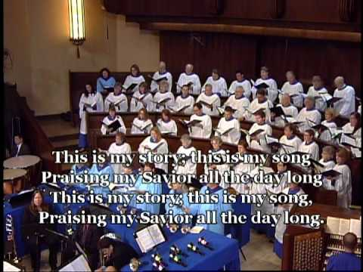

THE LIFE OF THE CHURCH
Potluck Hosts needed: June 21st is Potluck Sunday at our church. However, we do not have a host/s for that day. Please consider being host, or sharing that responsibility with another person. It makes all the difference in the world!

During the Pandemic, Face Masks: Several people in our church are making protective face masks for us to wear in public from fabric. If you need one, please let me know. I have 3 new ones available and more are being made!

Please,
Pray for peace in the Middle East, including Iraq and Afghanistan
Pray for a safe return of daughters and sons from combat
Pray for our global community and those in the midst of disaster
Pray for America and her enemies, that all would seek peace!
Pray for all the people and leaders in our local community
Pray for those who are seeking a deeper spiritual life.
Pray for all first responders
Pray for our church, national and local
Pray for our Presbytery and our pastor

PRAYER REQUESTS FOR COMFORT AND HEALING
Betty (Glenda’s sister) – awaiting a diagnosis
Cheryl Brewer – cancer hospice
Emma Lowther, Lou Sims’ great niece – ongoing heart trouble
Davis (Russell’s son) – shipping out to Air Force boot camp in San Antonio
Glenda Coles – broken foot and injured knee
Gloria (Teresa Gallegos-Brake’s sister) – still having health problems
Gracie Whitson – still recovering
Ida Macias – broken femur
Jenna Morris, knee problems
Jim Enriquez & family - medical problems
Julie Sursa – difficulty walking
Karen Foster – chemo for cancer
Kaylie McKnight and her family
Konnor (grandson of the Bonds) – at sea in the Navy
Kurt Goldston - chemotherapy
Levi Mericle – thyroid cancer
Misty Tompkins – stiff person syndrome
Nancy Sallee – two health problems
Family and friends grieving for Paul Quintana
Roseann Mendez battling liver cancer
Ruth Johnson – physical problems
Sharon Huffman – continued health problems
Sharon McCauley – awaiting surgery
Shay – requested by Julie Sursa
Sheila Martinez – Heart Trouble, diabetes, vision problems
Sondra Moore Carlson – chemotherapy
Sonia (Betty Faye’s daughter) recovering from stroke
Stacie (Glenda’s friend) – medical problems
The Montgomery family – at the loss of Harold
Tom Anderson – chemotherapy and side effects

